

Mohd. Razia Alangir Banu
D. VENKAT SAI
2520090034
CSIT
CO-2

Case Study : Warehouse Management & Analytical Query System
- Designed a warehouse dataset model with product ID, quantity, and sales logs
- Implemented B-Tree/B+ Tree conceptually for indexing large records
- Implemented Segment Tree for range-based queries (min/max/sum)
- Implemented Fenwick Tree for prefix sum analytics (daily sales tracking)
- Compared performance of each structure based on query type
- Verified time complexity efficiency using sample dataset operations
- Demonstrated correct selection of tree based on use-case (indexing vs analytics)

Implementation Details
- Product and sales data are logically organized using tree-based indexing for fast retrieval.
- B-Tree/B+ Tree concept is used for disk-friendly storage with multi-key nodes and balanced height.
- Segment Tree is implemented for interval queries like total stock or max shipment in a range.
- Fenwick Tree is used for prefix sum operations such as cumulative daily sales tracking.
- Update operations propagate efficiently using logarithmic time complexity structures.
- System ensures optimized performance with O(log n) query and update operations for all dynamic operations.

Output:
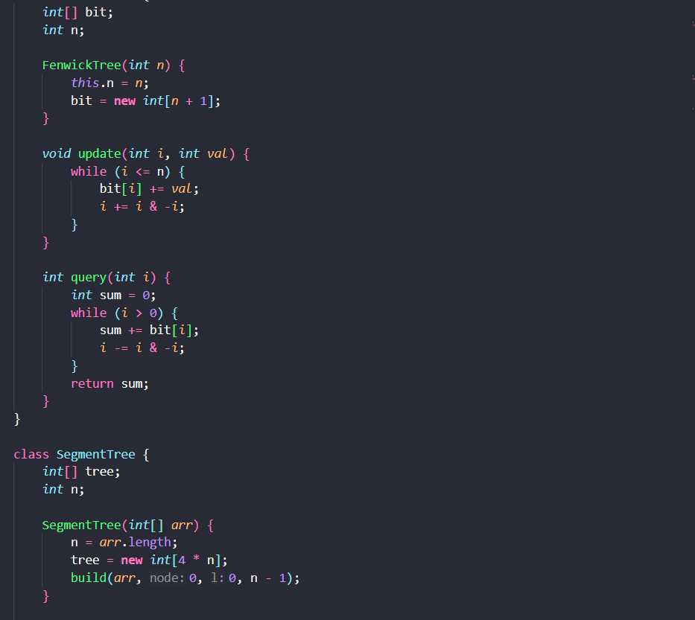
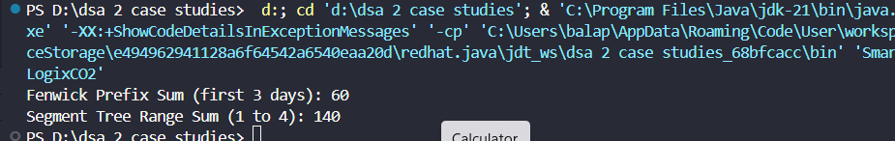

The system uses B+ Trees for indexing, Fenwick Tree for prefix sum queries, and Segment Tree for range queries. These data structures ensure efficient O(log n) operations, improving fast data retrieval, analytics, and overall scalability in warehouse management.

Github link: https://github.com/balapranithamallavarapu-cmyk/DSA-II-Case-Studies

